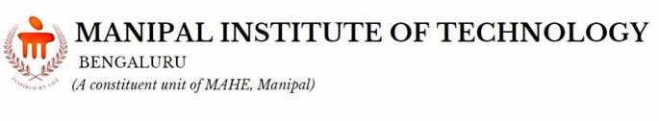
School of Computer Engineering
Machine Learning Lab (CSE_3146)
Mini Project Proposal
Student Name & Reg. No:
Vinayak Sharma(235890466)
Mohammad Zafar(235890292)

Dept/Branch: 3rd year AI-B

Project Title: Facial Recognition Application.

- Background / Motivation:
The ability to accurately and efficiently identify individuals from images or videos has become crucial in many modern applications, from security systems to biometric authentication. This project is motivated by the challenge of building a robust facial recognition system that can distinguish between faces with high accuracy, even with limited training data. This proposal outlines the development of a solution from scratch using a deep learning approach.

- Objectives:
- The primary objectives of this project are:
- To set up a complete development environment for a deep learning project.
- To build and train a Neural Network to accurately identify and differentiate between faces.
- To create a functional application that can perform facial recognition in real-time.

3. Proposed Methodology / Approach:
The project will follow an incremental development approach. The methodology is based on the principles of deep learning and will utilize the following tools and techniques:
- Framework: The project will be implemented using TensorFlow and Keras for building and training the deep learning model.
- Libraries: Key libraries to be used include OpenCV for image processing, NumPy for numerical operations, and Matplotlib for data visualization.
- Dataset: The model will be trained on a custom dataset consisting of anchor, positive, and negative images to teach the network to recognize facial similarities and differences.
- Model: A Neural Network will be designed and trained to generate embeddings for face images. The network will learn to produce similar embeddings for the same person and different embeddings for different people.
- Implementation: A graphical user interface will be developed to allow users to interact with the facial recognition system.

4.Expected Outcomes / Scope:
The expected outcome of this project is a functional facial recognition application .
- The trained deep learning model.
- Source code for the complete application, including the model and the user interface.
- A final project report detailing the methodology, results, and conclusions.

Keywords: Machine Learning , Deep Learning , Facial Recognition, Neural Networks, TensorFlow

